

***University of engineering and technology, Lahore***

***(Narowal Campus)***

***Project Report***

***ECAT Test Application***

***Presented By:***

1. *Amna Chaudhry (2021-Cs-513)*
2. *Tuba Faryal (2021-Cs-515)*
3. *Zargham Elahi (2021-Cs-518)*
4. *Azhar Hayat(2021-Cs-537)*
5. *Zainb Atif (2021-Cs-551)*

***Presented To:***

Mam Fatima Shahzadi (Computer science & Engineering Department)

***Table of Content***

|  |
| --- |
| 1. Acknowledgment |
| 1. Introduction |
| 1. Program Flowcharts |
| 1. Source code |
| 1. Outputs |
| 1. Bibliography |
| 1. Conclusion |

**Project Report**

**Acknowledgement:**

**Title of Project:** ECAT Test Application

**Object of Project:** To conduct the entry test for university of engineering and technology.

The student will enter his data inside the system and select the course from the given option and start the test after completing the test student can check his detail result in result section.

**Hardware Requirements:**

No special hardware is required for the application however some basic hardware of computer is required.

|  |  |
| --- | --- |
| Special hardware component | Null |
| Key board | yes |

**Software Requirements:**

Following are the software requirement for the system:

|  |  |
| --- | --- |
| Programming language | Assembly language |
| Software | Emu 8086 |
| Operating system | Windows |
| Memory | 1 MB |

**Objective Achievements:**

All the objective have been achieved successfully expect the database as the assembly language does support the database efficiently so this run base application.

**Note:** system contain the single .ASM file which is the main file and can be opened by emu8086.

**Introduction**

The proposed project is design to conduct the entry test for the University of Engineering and technology Lahore.

The project contain the following modules:

* **Start Test**
* **Check result**
* **Exit**

The program have the following function:

* **Get data()**
* **Newline ()**

The aim of the function is to get student data such as the Name, roll number etc.

On entering the choice it will run the different function however we have to start the test first in order to check the result else it will generate the Null or garbage values.

**Description and implementation of the program:**

**Header file:**

Header file emu8086.inc is added to system in order to access the following functions

* Print function ()
* Scan num function ()
* Print num function ()

**.Data:**

This section contain the all the variables that is to be used in the main source program. All the variable are declared in bits size.

Here is the variable section in emu8086 named as the .data section

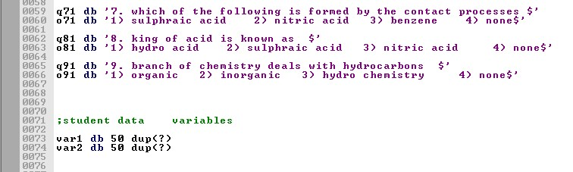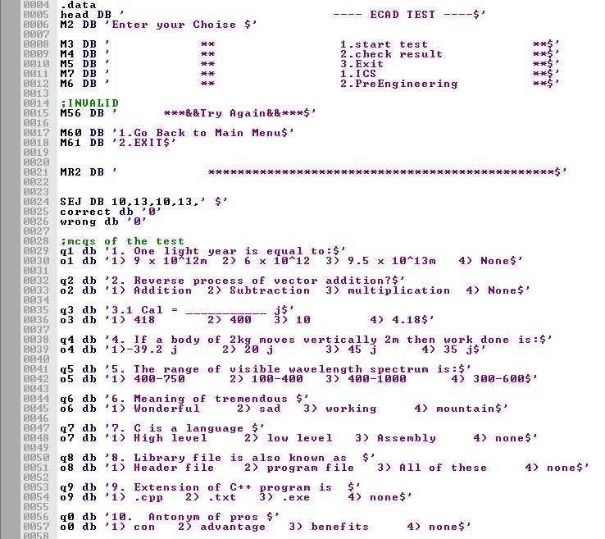

**.data section of variables used in the system**

**Note:** In the main section whole .data section must be moved to Data segment register named as the DS register.

**.Code:**

This section contain the all main source program, functions and define directives

First of all its will when you run the code the it will call the function that are defined at the end of source called named as procedures. This procedure is used to get the data from the student.

Following code is showing the get data procedure.

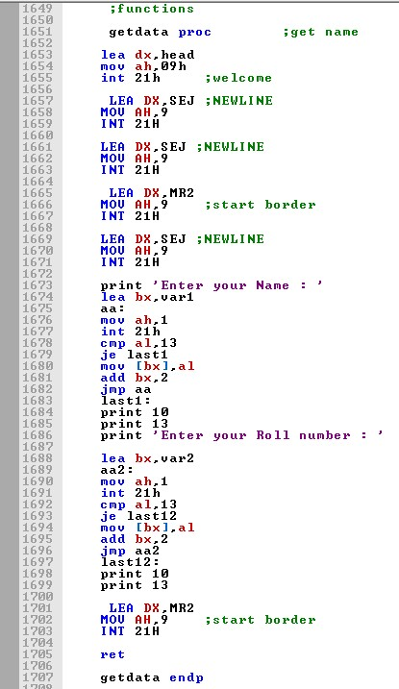

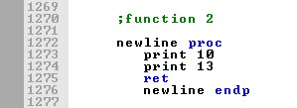

**Note:** Call function is used to call the function or procedure from source code.

**Define Directives:**

These are the function definition of different function used in the program. Following image display these directives.

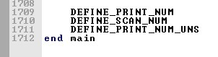

**Program Flowchart**

Flow chart define the flow of data in the source code.

Following table show the symbols terminology:

|  |  |
| --- | --- |
|  | Start / End |
|  | Processes |
|  | Decision making |
|  | Input / output |

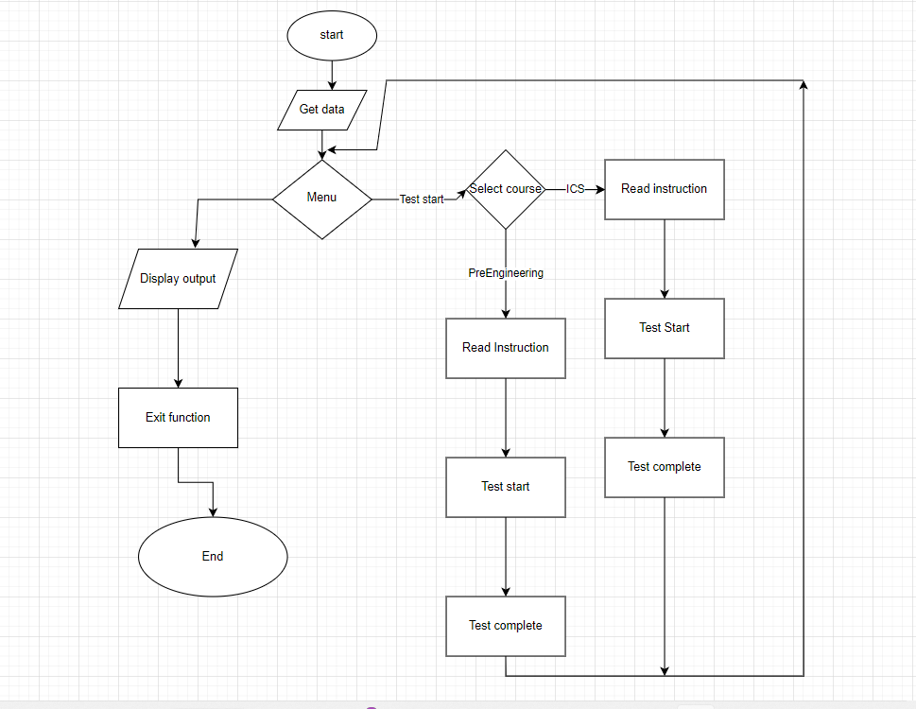

**Basic flow chart towards ECAT application**

The flow of chart start from the top and get the data from the students using the procedure as discussed above. This user has to make the choice from the option to start test or to check the result but it is recommended the first the user should give the test so that marks should be calculated according to the test otherwise it will display null or garbage values. After starting the test user has to make selection between two courses and then he can start the test and after completing the test he can check his complete result which will display total marks, obtain marks, wrong question and the final arks after the negative marking. If user fail to get 5 marks his marks will be considered as 0.

**ER diagram:**

This diagram display the relationship of different **entities** in the sources program.

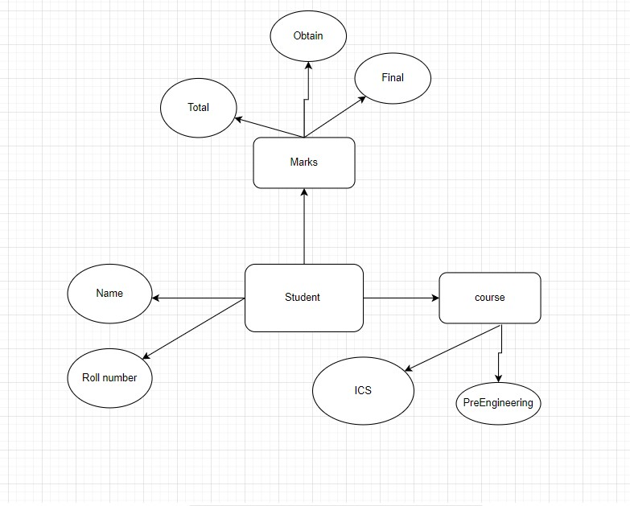

**Terminologies:**

The main entity is the student while the shapes in oval are displaying the attributes of the entities.

**Source code**

|  |  |
| --- | --- |
| .code  main proc  mov ax,@data  mov ds,ax  mov ax,0    call getdata  top:    mov ax, 3 ;clear screen  int 10h    call newline    lea dx,head  mov ah,09h  int 21h ;welcome    call newline  call newline    LEA DX,MR2  MOV AH,9 ;start border  INT 21H  call newline    ;menu  LEA DX,M3  MOV AH,9  INT 21H  call newline    LEA DX,M4  MOV AH,9 ;menu  INT 21H  call newline    LEA DX,M5  MOV AH,9  INT 21H  call newline    int 21h ;welcome  call newline  LEA DX,MR2  MOV AH,9 ;start border  INT 21H  call newline    LEA DX,M7  MOV AH,9 ;menu  INT 21H  call newline    LEA DX,M6  MOV AH,9 ;menu  INT 21H  call newline    LEA DX,MR2  MOV AH,9 ;start border  INT 21H  call newline    print 'Enter your choice : '  mov ah,01  int 21h  mov bl,al ;get choice  sub bl,48    cmp bl,1  je ics  cmp bl,2  je engineering  jmp error    ;---------------------ics    ics:    mov ax, 3 ;clear screen  int 10h    lea dx,head  mov ah,09h    LEA DX,MR2 ;  MOV AH,9 ;start border ;  INT 21H  call newline ;  ;  print 'enter your answer' ;  mov ah,01 ;  int 21h ;  mov bl,al ;  sub bl,48 ;  cmp bl,3 ;  je c1 ;  inc wrong ;  jmp end1 ;  c1: ;  inc correct ;  end1:  mov ax, 3 ;clear screen ;  int 10h ;  ;  call newline ;  ;  LEA DX,MR2 ;  MOV AH,9 ;start border ;  INT 21H ;  call newline ;  ;  LEA DX,q2 ;question ;  MOV AH,9  INT 21H ;  call newline ;  ;  LEA DX,o2 ;question ;  MOV AH,9 ;  INT 21H ;  call newline ;  ;  LEA DX,MR2 ;  MOV AH,9 ;start border ;  sub bl,48 ;  cmp bl,1 ;  je c3 ;  inc wrong ;  jmp end3 ;  c3: ;  inc correct ;  end3:          mov ax, 3 ;clear screen ;  int 10h ;  ;  call newline ;  ;  LEA DX,MR2 ;  MOV AH,9 ;start border ;  INT 21H ;  call newline ;  ;  LEA DX,q4 ;question ;  MOV AH,9  INT 21H ;  ; question 4  call newline ;  ;  LEA DX,o4 ;question ;  MOV AH,9 ;  INT 21H ;  call newline ;  ;  LEA DX,MR2 ;  MOV AH,9 ;start border ;  INT 21H  call newline ;  ;  print 'enter your answer' ;  mov ah,01 ;  int 21h ;  mov bl,al ;  sub bl,48 ;  jmp end5 ;  c5: ;  inc correct ;  end5:        mov ax, 3 ;clear screen ;  int 10h ;  ;  call newline ;  ;  LEA DX,MR2 ;  MOV AH,9 ;start border ;  INT 21H ;  call newline ;  ;  LEA DX,q6 ;question ;  MOV AH,9  INT 21H ;  call newline ;  ;  LEA DX,o6 ;question ;  MOV AH,9 ;  INT 21H ;  ;  call newline ;  ;  LEA DX,MR2 ;  MOV AH,9 ;start border ;  INT 21H    call newline ;  ;  print 'enter your answer' ;  mov ah,01 ;  int 21h ;  mov bl,al ;  sub bl,48 ;  cmp bl,1 ;  je c6 ;  inc wrong ;  jmp end6 ;  c6: ;  int 10h ;  call newline ;  ;  LEA DX,MR2 ;  MOV AH,9 ;start border ;  INT 21H ;  call newline ;  ;  LEA DX,q8 ;question ;  MOV AH,9  INT 21H ;  ; question 8  call newline ;  ;  LEA DX,o8 ;question ;  MOV AH,9 ;  INT 21H ;  call newline ;  ;  LEA DX,MR2 ;  MOV AH,9 ;start border ;  INT 21H  call newline ;  ;  print 'enter your answer' ;  mov ah,01 ;  int 21h ;  mov bl,al ;  sub bl,48 ;  cmp bl,1 ;  je c8 ;  inc wrong ;  jmp end8 ;  c8: ;  inc correct ;  end8:      mov ax, 3 ;clear screen ;  int 10h ;  call newline ;  ;  LEA DX,MR2 ;  MOV AH,9 ;start border ;  call newline ;  ;  LEA DX,o0 ;question ;  MOV AH,9 ;  INT 21H ;  call newline ;  ;  LEA DX,MR2 ;  MOV AH,9 ;start border ;  INT 21H    ;  LEA DX,SEJ ;NEWLINE ;  MOV AH,9 ;  INT 21H ;  ;  print 'enter your answer' ;  mov ah,01 ;  int 21h ;  mov bl,al ;  sub bl,48 ;  cmp bl,4 ;  je c10 ;  inc wrong ;  jmp end10 ;  c10: ;  inc correct ;  end10:      mov ax, 3 ;clear screen  int 10h  call newline    print 'congrulation you have completed the Test'  jmp top            engineering:    call newline ;  ;  LEA DX,MR2 ;  MOV AH,9 ;start border ;  INT 21H ;  call newline ;  ;  LEA DX,q1 ;question ;  MOV AH,9  INT 21H ;  ; question 1  call newline ;  ;  LEA DX,o1 ;question ;  MOV AH,9 ;  INT 21H ;  call newline ;  ;  LEA DX,MR2 ;  MOV AH,9 ;start border ;  INT 21H    call newline ;  ;  print 'enter your answer' ;  mov ah,01 ;  int 21h ;  mov bl,al ;  sub bl,48 ;  cmp bl,3 ;  je c11 ;  inc wrong ;  jmp end11 ;  c11: ;  inc correct ;  end11:          mov ax, 3 ;clear screen ;  int 10h ;  ;  ;  LEA DX,MR2 ;  MOV AH,9 ;start border ;  INT 21H ;  call newline ;  ;  LEA DX,q3 ;question ;  MOV AH,9  INT 21H ;  call newline ;  ;  LEA DX,o3 ;question ;  MOV AH,9 ;  INT 21H ;  call newline ;  ;  LEA DX,MR2 ;  MOV AH,9 ;start border ;  INT 21H  call newline ;  ;  print 'enter your answer' ;  mov ah,01 ;  int 21h ;  mov bl,al ;  sub bl,48 ;  cmp bl,4 ;  je c31 ;  inc wrong ;  jmp end31 ;  c31: ;  inc correct ;  end31:      mov ax, 3 ;clear screen ;  int 10h ;  call newline ;  ;  LEA DX,MR2 ;  MOV AH,9 ;start border ;  INT 21H ;  call newline ;  ;  LEA DX,q4 ;question ;  ;  LEA DX,o5 ;question ;  MOV AH,9 ;  INT 21H ;  call newline ;  ;  LEA DX,MR2 ;  MOV AH,9 ;start border ;  INT 21H  call newline ;  ;  print 'enter your answer' ;  mov ah,01 ;  int 21h ;  mov bl,al ;  sub bl,48 ;  cmp bl,4 ;  je c51 ;  inc wrong ;  jmp end51 ;  c51: ;  inc correct ;  end51:        mov ax, 3 ;clear screen ;  int 10h ;  call newline ;  ;  LEA DX,MR2 ;  MOV AH,9 ;start border ;  INT 21H ;  call newline ;  ;  LEA DX,q6 ;question ;  MOV AH,9  INT 21H ;  ; question 6  call newline ;  ;  LEA DX,o6 ;question ;  MOV AH,9 ;  INT 21H ;  ;  print 'enter your answer' ;  mov ah,01 ;  int 21h ;  mov bl,al ;  sub bl,48 ;  cmp bl,4 ;  je c71 ;  inc wrong ;  jmp end71 ;  c71: ;  inc correct ;  end71:      mov ax, 3 ;clear screen ;  int 10h ;  call newline ;  ;  LEA DX,MR2 ;  MOV AH,9 ;start border ;  INT 21H ;  call newline ;  ;  LEA DX,q81 ;question ;  MOV AH,9  INT 21H ;  ; question 8  call newline ;  ;  LEA DX,o81 ;question ;  MOV AH,9 ;  INT 21H ;  call newline ;  ;  LEA DX,MR2 ;  MOV AH,9 ;start border ;  INT 21H  call newline ;  ;  print 'enter your answer' ;  mov ah,01 ;  int 21h ;  mov bl,al ;  inc wrong ;  jmp end91 ;  c91: ;  inc correct ;  end91:  mov ax, 3 ;clear screen ;  int 10h ;  call newline ;  ;  LEA DX,MR2 ;  MOV AH,9 ;start border ;  INT 21H ;  call newline ;  ;  LEA DX,q0 ;question ;  MOV AH,9  INT 21H ;  ; question 10  call newline ;  ;  LEA DX,o0 ;question ;  MOV AH,9 ;  INT 21H ;  ;  call newline ;  ;  LEA DX,MR2 ;  MOV AH,9 ;start border ;  INT 21H    call newline ;  ;  print 'enter your answer' ;  mov ah,01 ;  int 21h ;  mov bl,al ;  sub bl,48 ;  cmp bl,4 ;  je c101 ;  inc wrong ;  jmp end101 ;  c101: ;  inc correct ;  end101:      add bx,2  loop bbbc  call newline    print 'Student Roll : '        lea bx,var2    mov cx,15  bbbb:  mov dl,[bx]    mov ah,2h  int 21h  add bx,2  loop bbbb  call newline        print 'total marks : 10'  call newline    print 'obtain marks : '  mov ah,0  mov al,correct  call print_num    call newline    print 'wrong questions : '  mov ah,0  mov al,wrong  call print_num  call newline    print 'Final marks : '  mov ah,0  mov al,correct  LEA DX,MR2  MOV AH,9 ;start border  INT 21H  call newline    print 'Enter your Name : '      lea bx,var1  aa:  mov ah,1  int 21h  cmp al,13  je last1  mov [bx],al  add bx,2  jmp aa  last1:  print 10  print 13  print 'Enter your Roll number : '      lea bx,var2  aa2:  mov ah,1  int 21h  cmp al,13  je last12  mov [bx],al  add bx,2  jmp aa2  last12:  print 10  print 13    LEA DX,MR2  MOV AH,9 ;start border  INT 21H    ret    getdata endp | LEA DX,MR2  MOV AH,9 ;start border  INT 21H  call newline    print 'Enter your choice : '  mov ah,01  int 21h  mov bl,al ;get choice  sub bl,48  cmp bl,1  je starttest    cmp bl,2  je result    cmp bl,3  je last    jmp error                            ;-----------------------------------------------------------start test---------------------------------------  starttest:  mov ax, 3 ;clear screen  int 10h    lea dx,head  mov ah,09h  call newline    LEA DX,MR2  MOV AH,9 ;start border  INT 21H  call newline    print 'Instructions'  call newline    print ' This test contain 10 MCQS'  call newline    print ' Test has Negative marking'  call newline    LEA DX,MR2  MOV AH,9 ;start border  INT 21H  call newline  print 'Press any Number to start test'    mov ah,01  int 21h  mov correct,0  mov wrong,0    mov ax, 3 ;clear screen ;  int 10h ;  ;  print ' test started ' ;  call newline ;  ;  LEA DX,MR2 ;  MOV AH,9 ;start border ;  INT 21H ;  call newline ;  ;  LEA DX,q1 ;question ;  MOV AH,9  INT 21H ;  call newline  int 21h ;welcome  INT 21H  call newline ;  ;  print 'enter your answer' ;  mov ah,01 ;  int 21h ;  mov bl,al ;  sub bl,48 ;  cmp bl,4 ;  je c2 ;  inc wrong ;  jmp end2 ;  c2: ;  inc correct ;  end2:    mov ax, 3 ;clear screen ;  int 10h ;  call newline ;  ;  LEA DX,MR2 ;  MOV AH,9 ;start border ;  INT 21H ;  call newline ;  ;  LEA DX,q3 ;question ;  MOV AH,9  INT 21H ;  call newline ;  ;  LEA DX,o3 ;question ;  MOV AH,9 ;  INT 21H ;  call newline ;  ;  LEA DX,MR2 ;  MOV AH,9 ;start border ;  INT 21H  call newline ;  ;  print 'enter your answer' ;  mov ah,01 ;  int 21h ;  mov bl,al ;  cmp bl,4 ;  je c4 ;  inc wrong ;  jmp end4 ;  c4: ;  inc correct ;  end4:      mov ax, 3 ;clear screen ;  int 10h ;  ;  call newline ;  ;  LEA DX,MR2 ;  MOV AH,9 ;start border ;  INT 21H ;  call newline ;  ;  LEA DX,q5 ;question ;  MOV AH,9  INT 21H ;  ; question 5  call newline ;  ;  LEA DX,o5 ;question ;  MOV AH,9 ;  INT 21H call newline ;  ;  LEA DX,MR2 ;  MOV AH,9 ;start border ;  INT 21H    call newline ;  ;  print 'enter your answer' ;  mov ah,01 ;  int 21h ;  mov bl,al ;  sub bl,48 ;  cmp bl,2 ;  je c5 ;  inc wrong ;    inc correct ;  end6:    mov ax, 3 ;clear screen ;  int 10h ;  call newline ;  ;  LEA DX,MR2 ;  MOV AH,9 ;start border ;  INT 21H ;  call newline ;  ;  LEA DX,q7 ;question ;  MOV AH,9  INT 21H ;  ; question 7  call newline ;  ;  LEA DX,o7 ;question ;  MOV AH,9 ;  INT 21H ;  call newline ;  ;  LEA DX,MR2 ;  MOV AH,9 ;start border ;  INT 21H  call newline ;  ;  print 'enter your answer' ;  mov ah,01 ;  int 21h ;  mov bl,al ;  sub bl,48 ;  cmp bl,4 ;  je c7 ;  inc wrong ;  jmp end7 ;  c7: ;  inc correct ;  end7:      mov ax, 3 ;clear screen ;  INT 21H ;  call newline ;  ;  LEA DX,q9 ;question ;  MOV AH,9  INT 21H ;  ; question 9  call newline ;  ;  LEA DX,o9 ;question ;  MOV AH,9 ;  INT 21H ;  call newline ;  ;  LEA DX,MR2 ;  MOV AH,9 ;start border ;  INT 21H  call newline ;  ;  print 'enter your answer' ;  mov ah,01 ;  int 21h ;  mov bl,al ;  sub bl,48 ;  cmp bl,1 ;  je c9 ;  inc wrong ;  jmp end9 ;  c9: ;  inc correct ;  end9:    mov ax, 3 ;clear screen ;  int 10h ;  call newline ;  ;  LEA DX,MR2 ;  MOV AH,9 ;start border ;  INT 21H ;  call newline ;  ;  LEA DX,q0 ;question ;  MOV AH,9  INT 21H ;  mov ax, 3 ;clear screen  int 10h    lea dx,head  mov ah,09h  int 21h ;welcome    call newline  LEA DX,MR2  MOV AH,9 ;start border  INT 21H    call newline    print 'Instructions'    call newline    print ' This test contain 10 MCQS'    call newline    print ' Test has Negative marking'    call newline    LEA DX,MR2  MOV AH,9 ;start border  INT 21H    call newline    print 'Press any Number to start test'    mov ah,01  int 21h    mov correct,0  mov wrong,0    mov ax, 3 ;clear screen ;  int 10h ;  ;  print ' test started ' ;  ;  call newline ;  ;  LEA DX,MR2 ;  MOV AH,9 ;start border ;  INT 21H ;  ;  call newline ;  ;  LEA DX,q2 ;question ;  MOV AH,9  INT 21H ;  ; question 2  call newline ;  ;  LEA DX,o2 ;question ;  MOV AH,9 ;  INT 21H ;  call newline ;  ;  LEA DX,MR2 ;  MOV AH,9 ;start border ;  INT 21H    call newline ;  ;  print 'enter your answer' ;  mov ah,01 ;  int 21h ;  mov bl,al ;  sub bl,48 ;  cmp bl,4 ;  je c21 ;  inc wrong ;  jmp end21 ;  c21: ;  inc correct ;  end21:      mov ax, 3 ;clear screen ;  int 10h ;  call newline ;  ;  MOV AH,9  INT 21H ;  ; question 4  call newline ;  ;  LEA DX,o4 ;question ;  MOV AH,9 ;  INT 21H ;  call newline ;  ;  LEA DX,MR2 ;  MOV AH,9 ;start border ;  INT 21H  call newline ;  ;  print 'enter your answer' ;  mov ah,01 ;  int 21h ;  mov bl,al ;  sub bl,48 ;  cmp bl,4 ;  je c41 ;  inc wrong ;  jmp end41 ;  c41: ;  inc correct ;  end41:      mov ax, 3 ;clear screen ;  int 10h ;  ;  call newline ;  ;  LEA DX,MR2 ;  MOV AH,9 ;start border ;  INT 21H ;  call newline ;  ;  LEA DX,q5 ;question ;  MOV AH,9  INT 21H ;  ; question 5  call newline ;  call newline ;  ;  LEA DX,MR2 ;  MOV AH,9 ;start border ;  INT 21H  call newline ;  ;  print 'enter your answer' ;  mov ah,01 ;  int 21h ;  mov bl,al ;  sub bl,48 ;  cmp bl,4 ;  je c61 ;  inc wrong ;  jmp end61 ;  c61: ;  inc correct ;  end61:    mov ax, 3 ;clear screen ;  int 10h ;  call newline ;  ;  LEA DX,MR2 ;  MOV AH,9 ;start border ;  INT 21H ;  call newline ;  ;  LEA DX,q71 ;question ;  MOV AH,9  INT 21H ;  ; question 7  call newline ;  ;  LEA DX,o71 ;question ;  MOV AH,9 ;  INT 21H ;  call newline ;  ;  LEA DX,MR2 ;  MOV AH,9 ;start border ;  INT 21H  call newline ;  sub bl,48 ;  cmp bl,4 ;  je c81 ;  inc wrong ;  jmp end81 ;  c81: ;  inc correct ;  end81:        mov ax, 3 ;clear screen ;  int 10h ;  call newline ;  ;  LEA DX,MR2 ;  MOV AH,9 ;start border ;  INT 21H ;  call newline ;  ;  LEA DX,q91 ;question ;  MOV AH,9  INT 21H ;  ; question 9  call newline ;  ;  LEA DX,o91 ;question ;  MOV AH,9 ;  INT 21H ;  call newline ;  ;  LEA DX,MR2 ;  MOV AH,9 ;start border ;  INT 21H    call newline ;  ;  print 'enter your answer' ;  mov ah,01 ;  int 21h ;  mov bl,al ;  sub bl,48 ;  cmp bl,4 ;  je c91 ;  mov ax, 3 ;clear screen  int 10h  call newline    print 'congrulation you have completed the Test'  jmp top                ;--------------------------------------------------------------result calculation---------------------------------        result:  mov ax, 3 ;clear screen  int 10h  call newline    LEA DX,MR2  MOV AH,9 ;start border  INT 21H  call newline    print 'Student Name : '          lea bx,var1    mov cx,15  bbbc:  mov dl,[bx]    mov ah,2h  int 21h  sub al,wrong  cmp al,5  js zero  call print_num  zero:  print '0'  call newline    LEA DX,MR2  MOV AH,9 ;start border  INT 21H  call newline  print 'press any key to return to main menu '  mov ah,1  int 21h  jmp top    jmp last      error:  print 'wrong input please try again '  jmp top    last:  mov ax,4C00h  int 21h  main endp      ;functions    getdata proc ;get name      lea dx,head  mov ah,09h  int 21h ;welcome    call newline  call newline      ;function 2    newline proc  print 10  print 13  ret  newline endp      DEFINE_PRINT_NUM  DEFINE_PRINT_NUM_UNS  end main |

**Output:**

Following are the output screens:

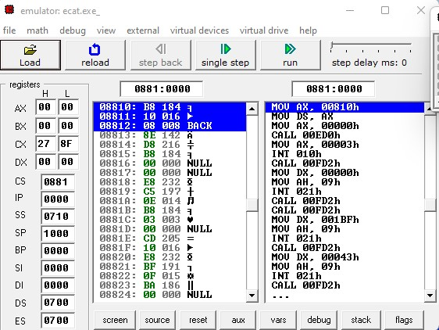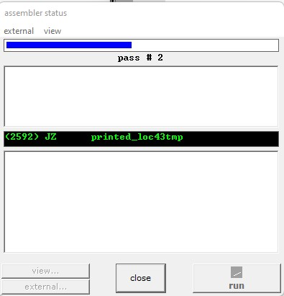

**Assembler test**

**Compilation complete**

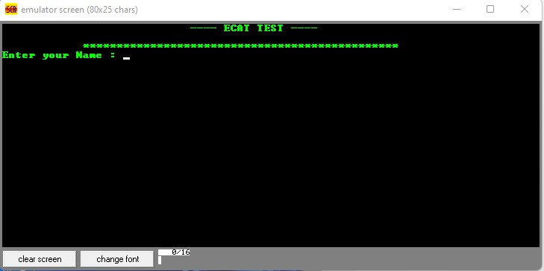

**Output**

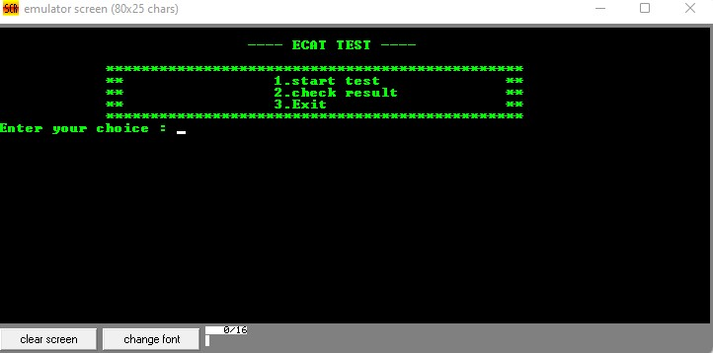

**Output menu**

**Bibliography**

Assembly language for x8086 Processors

Kip R. Irvine

Sixth edition

**Conclusion**

The main focus of the project is to improve the system interface with this new system.

**Thanks you!**



Computer Science & Engineering department